Customer Shopping Behavior Analysis Report
1. Project Overview
This project focuses on analyzing customer shopping behavior using transactional data from 3,900 purchases across multiple product categories. The objective is to identify spending patterns, customer segments, product preferences, and subscription behavior to support better business and marketing decisions.
2. Dataset Summary
- Total Records: 3,900
- Total Columns: 18
Key Features:
- Customer Demographics: Age, Gender, Location, Subscription Status
- Purchase Details: Item Purchased, Category, Purchase Amount, Season, Size, Color
- Shopping Behavior: Discount Applied, Promo Code Used, Previous Purchases, Purchase Frequency, Review Rating, Shipping Type
- Missing Data:
  - 37 missing values found in the Review Rating column
3. Exploratory Data Analysis using Python
Data preparation and exploratory analysis were carried out using Python to ensure the dataset was clean, consistent, and ready for analysis.
- Data Loading: The dataset was imported using the Pandas library.
- Initial Exploration: The structure and summary of the data were examined using df.info() and df.describe() to understand data types and distributions.
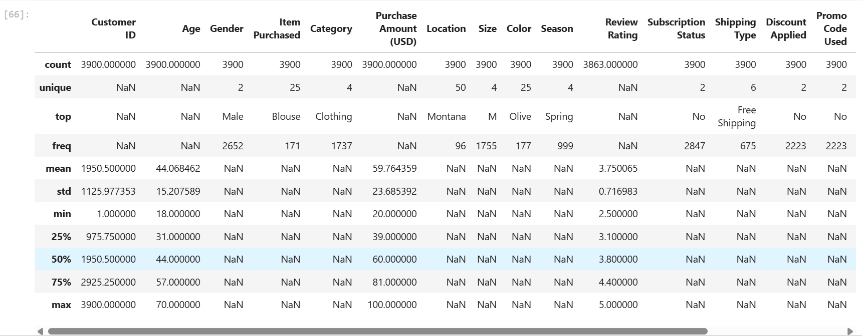

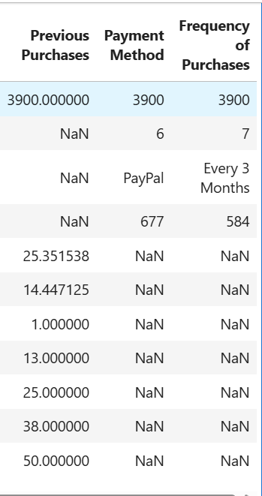

- Missing Data Handling: Missing values in the Review Rating column were identified and filled using the median review rating of each product category.
- Column Standardization: Column names were converted to snake_case to improve readability and maintain consistency.
- Feature Engineering:
  - Created an age_group column by grouping customer ages into defined ranges.
  - Created a purchase_frequency_days feature to better represent customer buying behavior.
- Data Consistency Check: Checked for redundancy between discount_applied and promo_code_used and removed the promo_code_used column.
- Database Integration: The cleaned dataset was stored in a PostgreSQL database to support further analysis using SQL.

4. Data Analysis using SQL (Business Transactions)
SQL analysis was performed using PostgreSQL to explore customer behavior and answer important business questions. The cleaned data was queried to extract meaningful insights related to revenue, customer segments, and purchasing patterns.
The following analyses were carried out:
- Revenue by Gender:
Compared total revenue generated by male and female customers to understand gender-based spending patterns.
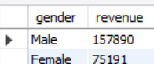
- High-Spending Discount Users:
Identified customers who used discounts but still spent more than the average purchase amount.
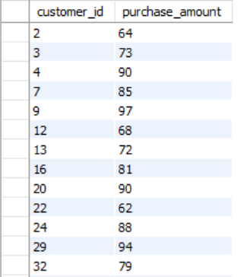
- Top 5 Products by Rating:
Determined the top five products with the highest average customer review ratings.
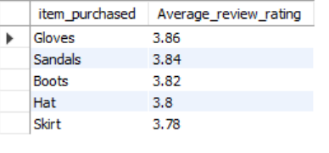
- Shipping Type Comparison:
Compared average purchase amounts between Standard and Express shipping methods.
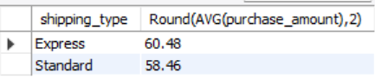
- Subscribers vs. Non-Subscribers:
Analyzed differences in average spending and total revenue based on subscription status.
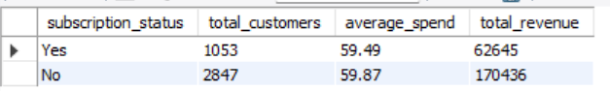
- Discount-Dependent Products:
Identified the five products with the highest percentage of discounted purchases.
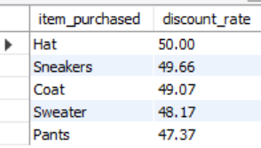
- Customer Segmentation:
Segmented customers into New, Returning, and Loyal categories based on their purchase history.
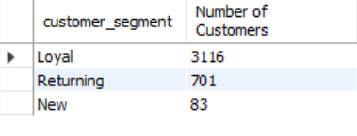
- Top 3 Products per Category:
Listed the top three most frequently purchased products within each product category.
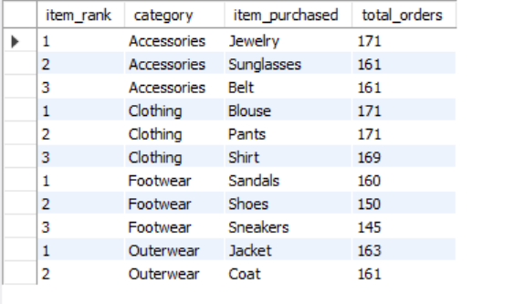
- Repeat Buyers and Subscriptions:
Examined whether customers with more than five purchases are more likely to subscribe.
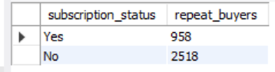
- Revenue by Age Group:
Calculated the total revenue contribution of each customer age group.
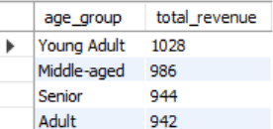

5. Dashboard in Power BI (Explanation & Insights)
An interactive Customer Behavior Dashboard was developed in Power BI to visually summarize key insights from the analysis. The dashboard allows users to filter data by subscription status, gender, category, and shipping type, making it easy to explore customer trends.
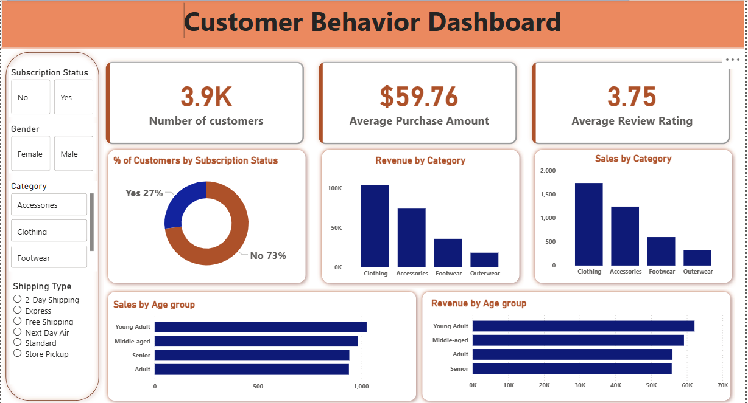
Key Dashboard Metrics
- Number of Customers: 3.9K
- Average Purchase Amount: $59.76
- Average Review Rating: 3.75
Key Insights from the Dashboard
- Subscription Status:
Around 27% of customers are subscribers, while 73% are non-subscribers, indicating scope for improving subscription adoption.
- Revenue & Sales by Category:
Clothing generates the highest sales and revenue, followed by Accessories, making them the strongest-performing categories.
- Age Group Analysis:
Young Adults and Middle-aged customers contribute the highest sales and revenue, making them key target segments.
- Customer Engagement:
Average review ratings indicate moderate satisfaction, suggesting opportunities to enhance customer experience.
- Interactivity:
Filters enable stakeholders to analyze trends across demographics, product categories, and shipping preferences in real time.
Business Value
The dashboard provides a clear and interactive view of customer behavior, helping decision-makers identify high-performing segments, optimize product strategies, and design targeted marketing campaigns.
6. Business Recommendations
Based on the analysis and dashboard insights, the following business recommendations are suggested:
- Boost Subscriptions: Promote exclusive offers and benefits for subscribers to encourage more customers to opt for subscription plans.
- Customer Loyalty Programs: Introduce rewards and incentives for repeat buyers to convert them into loyal customers.
- Review Discount Strategy: Use discounts strategically to increase sales while maintaining healthy profit margins.
- Product Positioning: Highlight top-rated and best-selling products in marketing campaigns to attract more customers.
- Targeted Marketing: Focus marketing efforts on high-revenue age groups and customers who prefer faster shipping options.

